60.11.20
From Joseph Hooker
RB MSS M3, Library, Royal Botanic Gardens Melbourne.

Kew Novr. 20th 1860
Dear Dr Mueller
I have received two letters from you since my departure for Syria & return here. I have now returned & the first thing I did was to send to Pamplin the £65, that you sent me for R.S. membership. I quite expect that you will be elected this coming year & then the Secretary will communicate direct with you about the fees.
I wrote to you from Jerusalem asking your kind aid towards introducing Australian trees into Palestine, by sending seeds to Consul Finn, which would prove an immense boon to the country.
I only returned two days ago & have not yet had time to look over your many valued communications that have arrived since my departure, I am however especially glad to see that the excellent elaborate & careful Flora of Victoria is making good progress.
You will be glad to hear that a genuine Scientific Natural History Review is about to be established, in which Mr Oliver our active & talented Librarian at Kew undertakes the Editorship of Phænogamic Botany & Mr Currey the Cryptogamic two better men could not be found any-where — The Review will appear quarterly & will be invaluable; — it will contain a quarterly bibliography of immense value.
My Father is remarkably well & is working as hard as ever at his Ferns: he takes immense interest in all your doings. Bentham has finished the mss of the Hong Kong Flora & printed down to end of Leguminosee. The first-volume of Grisebachs Flora has now appeared with Index of genera — It is most unlucky that he has followed an arrangement of the Orders of his own. I wish all would follow DC, not because it is necessarily the best, but because most do follow it, & all know how to find the orders by sequence without referring to the Index.
I am anxiously expecting your cases of plants by Sussex, & should be delighted to see Gahnia alive.
Ever, in haste
most truly yr
Jos. D Hooker.

Gahnia
Leguminosee

M to J. Hooker, June 1860 (in this edition as 60-06-00), and M to J. Hooker 24 August 1864.
See J. Hooker to M, 20 October 1860.
B62.03.03. M sent sheets, each of 8 pages, to Kew as he got them from the printer. Printing did not proceed beyond sheet 5.
On the history of the Natural history review, see DeArce (2012).
Bentham (1861a).
Leguminosae?
Grisebach (1864).
de Candolle (1823-73).
See M to W. Hooker, 25 August 1860 (in this edition as 60-08-25a).
Associated nowadays with this letter is a small sheet of blue paper, 11.6 cm wide x 9.0 cm deep, labelled 'For Dr. Mueller' with a pencil sketch, thus 60-11-20_image01.jpg 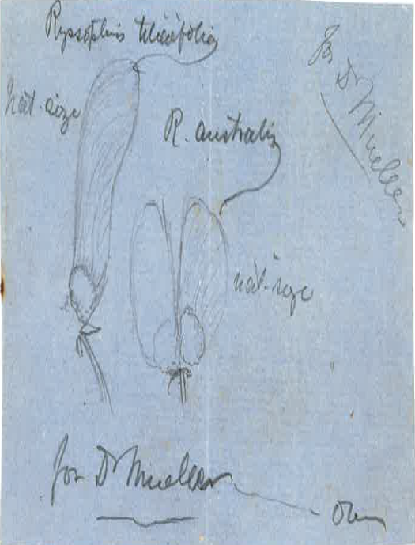 On the reverse is written: ''Ryssopterys australis is in the Hookerian Hb. from Cunningham (E. Coast, Trop.) and "Ryssopteris" is written on the label by Jussieu — but the species is not described by him — it appears to be a good species —‘ It is not clear in which letter from M's Kew correspondents this would have been included. Ryssopterys timorensis is discussed in M to G. Bentham, 20 February 1863 and G. Bentham to M, 25 April 1863. The only Australian species recognised by Bentham, Ryssopterys timorensis, is treated in Bentham (1863-78), vol. 1, p. 285, but neither R. australis nor R. tilaefolia (which M had mentioned in the letter of 20 February) is listed as a synonym.

